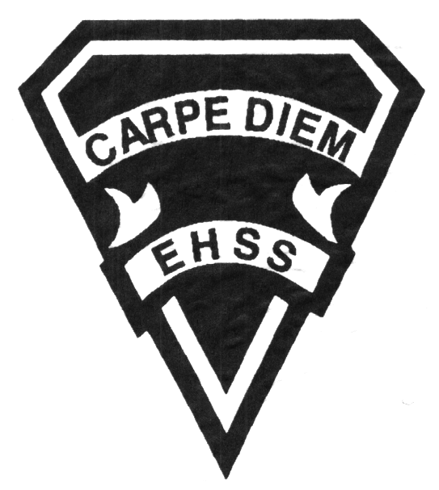

**2019/2020**

### World History to the Sixteenth Century

**Social Sciences Department**

## Earl Haig

SecondarySchool

# **CHW3M**

**Evaluation Profile & Outline**

**Course Description/Rationale/Overview:** This course investigates the history of humanity from the earliest times to the sixteenth century. Students will analyze diverse societies from around the world, with particular regard to the political, cultural and economic structures and historical forces that form the foundation of the modern world. Also examined, will be the influence of selected individuals and groups, as well as particular innovations, and will develop skills of historical inquiry, organization, analysis, and communication.

**Class Requirements:** Students should have materials specified by the subject teacher at the beginning of the year.

The textbook for this course is World Civilizations. Students will be issued this book at the beginning of the course. The replacement cost for this textbook $115.00.

**Assessment and Evaluation Strategies**

Students will also be expected to complete assessment activities of a formative nature in order to learn and to practice the specific expectations that will compose the summative evaluations. Examples of formative assessment may include homework checks, quizzes, peer assessment, presentations, reflection writing, role-play scenarios and observation.

Each unit or strand of the course will be evaluated using summative evaluations. Examples of summative evaluations are tests, case studies, interviews, reports, presentations, seminars, debates, research and other writing assignments.

**Late and/or Missed Evaluation**

##### Late Assignments*

For each assignment, the teacher will inform students of the due date. The teacher may decide to create an ultimate deadline. If an assignment *is submitted after the deadline, the teacher may deduct marks up to and including the full value of the assignment*

.

**Missed Tests**

It is the student’s responsibility to make arrangements, ahead of time, for any tests/quizzes that are missed. If a student misses a test/quiz for an unforeseen reason such as illness, the student must bring a note signed by a parent or guardian**. Alternatively a medical certificate may be requested by the teacher.** The student must be prepared to write the test/quiz immediately upon return to school at a time determined by the teacher. Once the tests/quizzes have been evaluated and returned, students will not be able to make up a missed test - a mark of zero will be assigned.

**Subject-Specific/Department Information**

Teachers in the Social Sciences Department can be reached at (416) 395-3210, ext. 20075 or 20085. Parents wishing to meet with a teacher are requested to make an appointment with the teacher prior to coming to the school.

**Learning Skills\***

**Responsibility** – meets deadlines; takes responsibility for own behaviour

**Organization** – establishes priorities and manages time; uses information, technology and resources top complete tasks time management

**Independent Work** – follows instruction with minimal supervision; uses class time appropriately to complete tasks

**Collaboration** – accepts an equitable share of work in a group; builds healthy peer relationships; works with others to achieve group goals

**Initiative** – looks for opportunities for learning; demonstrates curiosity; approaches new tasks with a positive attitude

**Self-regulation** – sets own goals and monitors own progress; seeks assistance with needed; makes an effort with responding to challenges

###### Final Mark

The final mark for this course will be determined based upon an accumulation of marks from unit summative activities and from a final summative evaluation

**Year’s Work 70%**

This is a culmination of evaluations that have been completed throughout the year. It may include tests, presentations, research, or topic specific assignments.

**Final Summative Evaluation 30%**

The summative for this course entails a final essay worth 15% of the total mark and comprehensive final exam worth 15% of the total mark.

**Achievement Categories and Weighting**

* **Knowledge / Understanding – 35%**

Knowledge of facts and terms; understanding of concepts, principles, guidelines and strategies; understanding of relationships among concepts.

* **Application – 20%**

Synthesizing knowledge and understanding into new and familiar contexts as well as making connections between various contexts.

* **Thinking Inquiry – 30%**

Formulating questions; planning, selecting strategies and resources; analyzing and interpreting information, and forming conclusions.

* **Communication – 15%**

Communication of information and ideas, communication for different audiences, use of various forms of communication.

*From: Ontario Ministry of Education. *Growing Success: Assessment, Evaluation, and Reporting in Ontario Schools*. Toronto: Ministry of Education, 2010, 11.



**2019/2020**

### World History to the Sixteenth Century

**Social Sciences Department**

## Earl Haig

SecondarySchool

# **CHW3M**

**Evaluation Profile & Outline**

**Course Outline:**

###### Unit 1: Humanity Before Civilization

Through their examination of current historical evidence, students will learn about the development of societies from the most simple to the most complex. They will examine the different roles of members of those societies in the early stages of human history, particularly during the Paleolithic and Neolithic historical periods. In this unit, students will be introduced to the process of historical inquiry, analysis and interpretation and will come to understand how these interpretations shape the way history is studied. Finally, students will examine the transition from hunter/gatherer societies to agricultural societies and evaluate the criteria a society must meet to be regarded as a civilization.

###### Unit 2: Near Eastern Civilizations

In this unit, students will discover why the earliest civilizations developed along the major river systems of Mesopotamia and Egypt. An in depth study of Mesopotamia and ancient Egypt will be undertaken in which the political organization, legal traditions, economic structure, technological development, social organization, cultural life and religious rituals and practices of these earliest civilizations are examined. The Indus Valley Civilization of India and the Yellow River Civilization of ancient China may also be studied as part of this unit.

###### Unit 3: The Mediterranean World

In this unit, students will have the opportunity to examine the two great civilizations of the Mediterranean world, Greece and Rome. They will study the development of Greek society from its humble beginning as a collection of agricultural communities to the “Golden Age” of classical Greece and the Hellenistic period. Its Minoan origins on the island of Crete will be studied along with the Myceaean period, the Archaic period leading to the classical age when Sparta and Athens were rivals for control of the Greek world. The rise of Rome as the influence of the Greeks began to decline, will be examined next and both the republican and imperial eras will be examined. Finally, the influence of both the Greeks and the Romans on western civilization today will be studied.

###### Unit 4: The Medieval World

In this unit, the Middle Ages in Europe will be examined with particular reference to the role of the Roman Church in the medieval world. The focus of study will be on the shift of political control after the collapse of the Roman Empire away from the Mediterranean basin to Northern Europe. Students will analyze how new social structures associated with feudalism emerged which lay the foundations for the political, social, cultural and religious systems that predominate today in the western world.

###### Unit 5: The Renaissance

In this final unit, students will examine the transition from the late Middle Ages period in Europe to the Renaissance with its re-emphasis of the classical heritage of Greece and Rome. Students will study how European contact with other cultures in Asia and the Middle East, particularly the Byzantine and Islamic civilizations contributed to the new ideas of the Renaissance in Europe and the western world.